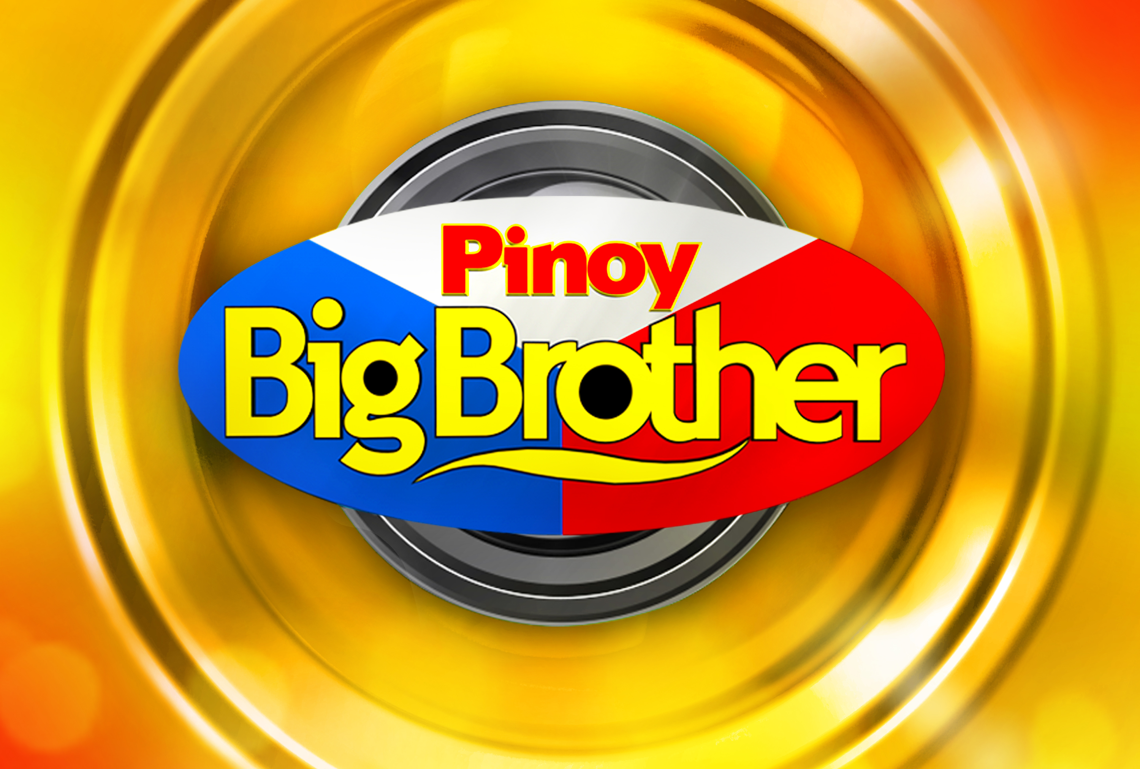

WAIVER AND RELEASE
NAME OF PARTICIPANT:
AGE :
ADDRESS :
AUDITION : As contestant in Pinoy Big Brother (PBB) Season 7 (the “Program”)

I certify the following:

- Eligibility and Participation

- I am between the ages of nineteen (19) to thirty five (35) years as of June 2016 until December 2016.
- I have voluntarily participated in the Audition conducted by ABS-CBN Corporation (“ABS-CBN”), without any compensation and I assume all risks arising from or associated with my participation in the Audition. As such, I have done or will be doing one or more of the following:

- Engage in one or more live performances or submit a video of myself online (“Online Video”), in connection with the Audition, during which my likeness or voice may be recorded in photograph, video or sound, or my Online Video will be uploaded in a platform specified by ABS-CBN (the “Platform”);
- Grant one or more interviews to ABS-CBN;
- Provide ABS-CBN a true account and disclosure of my name, address, civil status, education, and other personal information (the “Data”);
- Undergo physical, emotional, psychological and other tests and examinations by professionals selected by ABS-CBN, as part of the Audition; and
- Such similar activities as may be connected to the above.

- The procedure, rules and other material terms for participating in the Audition have been fully made known to me by the Program and/or ABS-CBN, or if I am submitting an Online Video, I have read the terms and conditions indicated in the Platform (the “Terms”). I accept and agree to be bound by the Terms.
- I am aware that a favorable endorsement during the medical, emotional and psychological tests shall entitle me to qualify for the Program; and that ABS-CBN has full and final authority to determine my eligibility and qualification to enter into and participate in the Audition, and in the Program, and that its decision thereon shall be final, binding and non-appealable.
- I am aware that if selected as a finalist in the Program, my participation in the Program shall include having to live in a house which is isolated from the outside world located at Eugenio Lopez Drive, Quezon City, Philippines (the “house”), for a period of approximately 17 weeks (“Estimated Duration”).

- Warranties

- I hereby warrant that I have the full power and authority to enter into and participate in the Audition, that I am a citizen of the Philippines, or if not, of Filipino lineage; that I am qualified to join the Audition in accordance with the Terms.
- If I am enrolled in school (the ‘School”), or if I reside outside Metro Manila, Philippines, or if I have an existing employment or engagement contract with a third party (the “Employer”), I warrant that I shall secure all necessary permissions, consents and authorizations from the School, or the Employer, and all the regulatory or government agencies, necessary for me to travel to Metro Manila, Philippines and/or participate in any phase of the Audition, and, in the event I am selected as a finalist, to participate in the Program for the Estimated Duration.
- I further warrant that I have no management or other agreement with any other person, firm or corporation, which will in any way interfere with my participation in the Audition, or with any of the rights of ABS-CBN. In the event that I am represented by a talent manager at the time of signing if this Waiver and Release, or submission of the Online Video (“Manager”), which I have disclosed to ABS-CBN, Manager shall likewise sign this Waiver and Release below. I and my Manager hereby agree that ABS-CBN, through Star Magic, shall have the option to enter into a management agreement with me, and upon such election by ABS-CBN/Star Magic, Manager and ABS-CBN/Star Magic shall co-manage my professional career. The terms of the management agreement shall be further explained to me at a future date, if I am selected to participate in additional phases of the Program.
- If I submitted an Online Video, I represent that such Online Video is original and does not violate or infringe upon the rights of any third parties, including, without limitation, any intellectual property rights and rights of publicity and/or privacy. I acknowledge that the Online Video submitted to ABS-CBN, may be used by ABS-CBN without restriction for any purpose whatsoever, including, without limitation, editing, reproduction, disclosure, transmission, publication, broadcast or posting, and I hereby irrevocably waive, release and give up any claim that any use of such violates any of my rights, including, without limitation, copyrights, trademarks, moral rights, privacy rights, proprietary or other property rights, publicity rights, or right to credit for the material or ideas.

- Non-Disclosure

- I acknowledge that I may be given access to or become acquainted with confidential information and trade secrets of ABS-CBN. I shall not disclose directly or indirectly to any third party any such confidential information and trade secrets of ABS-CBN, including the terms of this Waiver and Release and the terms and conditions of any contract that I may execute with ABS-CBN. This obligation shall survive my participation in the Audition, and will continue even if I am not selected as a finalist in the Program.
- If I am selected to be a finalist in the Program, I will not directly disclose such selection to any person, other than to my parents or legal guardian, or to my spouse, if I am married. I will not, nor through my parents or legal guardian, or spouse, consent to any interview, press release, issuance or any other public disclosure by any means or method, of such selection prior to the date that ABS-CBN designates for me to move into the house. I also acknowledge that prior to the broadcast of the Program, the plans of ABS-CBN for the Program, and any of the activities, results and developments in the Audition/Program (“Program Content”), are strictly confidential. I shall not disclose directly or indirectly to any third party any of the Program Content, unless such Program Content becomes or is made known to the public by the broadcast thereof by ABS-CBN.
- I shall not make public any complaint or grievance about the Audition, or the Program, including any decision made by ABS-CBN, and will take this up directly with ABS-CBN or its proper officers.

- Release and Acceptance

- In the event that I receive from ABS-CBN any prizes in excess of Ten Thousand Pesos (P10,000.00) (the “Prizes”), ABS-CBN shall withhold from the Prize/s the amount equivalent to twenty percent (20%) of the value of the Prize/s, which shall be remitted by ABS-CBN to the appropriate government agency as taxes due on the Prize/s.
- I am fully aware that the Program and ABS-CBN have not authorized any person to promise me any employment, contract, benefit, or any reward, and that if I decide to make any deal, arrangement or transaction with such unauthorized persons, I shall hold ABS-CBN free and harmless from any claim arising from my decision.
- I give permission to ABS-CBN to collect, use and share my Data with its affiliates, partners, sponsors and suppliers for the purposes of organizing the Audition and for the communication, production, exhibition, distribution, promotion and exploitation of the rights to the Program.
- I grant permission to the Program and to ABS-CBN to use my name, likeness, identity and appearance or participation in the Audition in any photographs, motion pictures, or any other record, such as but not limited to any Online Video, in any and all manner and media in perpetuity, throughout the world. I agree that such record of my participation in the Audition shall become the sole property of ABS-CBN, including copyright therein.
- I hereby release ABS-CBN, and any sponsors of the Program, and their respective officers, directors, employees, representatives, successors and assigns from any and all claims and damages I may have for invasion of privacy, defamation, damages, or any other cause of action arising out or relating to the Audition, or my participation in the Audition and the Program, and the duplication, distribution, broadcast or exhibition of my participation in the Audition and the Program.

- Liabilities

- Should I make any misrepresentation of any matter to ABS-CBN, violate any of my undertakings, warranties or obligations in this Waiver and Release, I shall be automatically disqualified from the Audition and from any possible inclusion in the Program, without prejudice to any other right or remedy ABS-CBN may have against me at law or equity.
- My failure to sign, or my Manager’s failure to sign (in case I am represented by a Manager), this Waiver and Release, or to comply with the foregoing conditions, shall be sufficient ground for my disqualification from the Audition, and the Program, and for ABS-CBN to take proper legal action against me, such as but not limited to a claim for damages. The absence of any information on, and the signature of, the Manager, on this Waiver and Release, shall be sufficient ground to consider me as not being represented by a Manager at the time of the Audition.

With my conformity:

Signature : _________________________________________
Printed Name of Participant : _________________________________________
Date : _________________________________________

If the person signing the Waiver and Release is represented by a talent manager, this Waiver and Release must be signed by the Manager.

I represent that I am the Manager of the Participant and hereby agree that we shall both be bound thereby.

Signature : _________________________________________
Printed Name of Manager : _________________________________________
Date : _________________________________________

